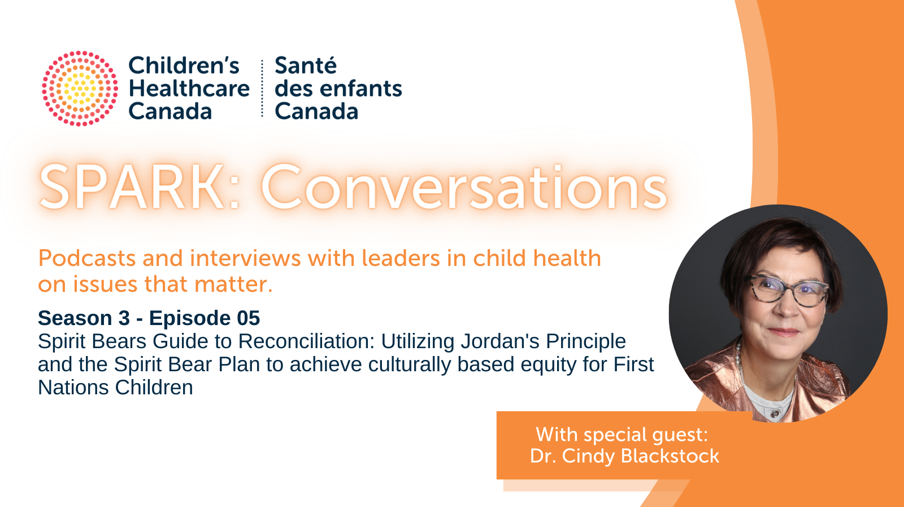

Transcript: Spirit Bears Guide to Reconciliation
Connected by purpose driven by passion. This is Children's Healthcare Canada’s Spark Conversations podcast series.

Katharine: Welcome to Spark Conversations, Children’s Healthcare Canada’s monthly podcast series. At the crossroads of children's health care system improvement and leadership, Spark Conversations is a solution focused podcast that connects the child and youth health community with system leaders who tackle wicked problems and discuss ideas to inform the development of innovative and integrated systems serving children and youth. Spark Conversations is one component of our Spark Knowledge Mobilization Program. Spark is the shared platform for Advocacy, Research, and Knowledge.

I'm Dr. Katherine Smart, and today I'm absolutely delighted to be speaking with a personal hero of mine, Dr. Cindy Blackstock. Cindy is the executive director and co founder of the First Nations Child and Family Caring Society of Canada, Associate professor and Director of First Nations Children's Action Research and Education Service at the University of Alberta and professor in McGill School of Social Work.

As a nationally and internationally respected advocate for the rights of indigenous children and a member of the gets in First Nation. Cindy has 25 years of social work experience in child protection and indigenous children's rights. Further, her research spans the identification and remediation of structural inequalities affecting First Nations children, youth, and families. As an author of over 50 publications, and a widely sought after public speaker, Cindy has collaborated with other Indigenous leaders to assist the United Nations Committee on the Rights of the Child in the development and adoption of a general comment on the Rights of Indigenous children.

Recently, she also worked with indigenous young people UNICEF, and the United Nations Permanent Forum on Indigenous issues to produce a youth friendly version of the United Nations Declaration on the Rights of the Child. Her promotion of culturally based and evidence informed Solutions has been recognized by the noble women's initiative, the Aboriginal achievement Foundation, frontline defenders, and many others.

Today we are chatting about an extremely important topic, Indigenous children's health. Hello, Cindy, and welcome to Spark Conversations.

Cindy: Hey, thank you, Katharine, nice to be here.

Katharine: As an internationally recognized First Nation scholar and child welfare expert, you have been the driving force behind promoting reconciliation. To ensure culturally based equity for First Nations children and families. Your leadership has been absolutely inspirational, and your steadfast moral courage has set the tone for all of us to put our children first, and to fight for the inequalities faced by First Nations children in Canada. You have been a trusted champion of First Nations Children's Rights for over a decade and showing us the power of creating new pathways which demand justice and a mindset that values true equality of funding, education and service for all children without exception.

So I've got a few questions for you Cindy, and, and as a pediatrician who works in Canada's north and is very fortunate to work with many First Nations, families and communities. I'm really excited to learn from you today and get your thoughts. So my first question is how can non Indigenous health care professionals like myself who work in pediatrics and work in First Nations communities, promote reconciliation and ensure culturally based equity and care for First Nations children and families?

Cindy: Well, thanks, Catherine. I think one of the first things is to understand where these inequalities come from. And a lot of folks aren't aware that the federal government funds First Nations Children's Services on reserve and in the Yukon Territory. And since Confederation, they have funded them at lesser levels, everything from basics like water and sanitation to education, early childhood, and child welfare, and health services. And so you have these compound inequalities that pile up on the hopes and dreams of families that are still trying to recover from the multi generational impacts of residential school. So where can you learn more about this kind of stuff?

Well, you can go onto our website we got lots of information sheets on something called the Spirit bear plan, which is the antidote to all these inequalities, basically calling on government to remedy cost out the inequalities and remedy them like treat kids fairly for the first time since Confederation. Second, of course, read the executive summaries even if you're short on time of the Truth and Reconciliation Commission, and the murdered and missing Indigenous women and girls and look at the Child Focused calls to action though calls to justice. And another big one, of course is in your practice is learn about Jordans principle, Jordans principles about making sure that First Nations children have access to the public sir versus a need when they need them. So you as a physician, if you see an unmet need of a First Nations child, you could write a recommendation for that child with the parents’ consent.

And you can even call Jordan's principal directly at 1855-JP-Child that's 1855-JP-Child and get funding for a health related support for a child, it could be an educational support or something like this respite, even for the home and get that funded through Jordans principle. So that's number one in your practice. And the other is kind of help us out advocating for culturally based services for First Nations kids from coast to coast and look to your local communities to see what their priorities are.

Katharine: Thank you for that. I think it's so critical that people understand the structural inequalities, as you've outlined, I think that's so key to understand that history. And, and as you've said, for me, Jordan's principle has been absolutely transformative in my ability to deliver care to my patients in the Yukon, and I email with them regularly. They're very responsive. And I absolutely agree, it's something every physician should be aware of is their ability to support families is really incredible. And just, you know, not only in health needs, but educational, social family needs, it's really a comprehensive program. So absolutely echo the importance of understanding and knowing how to access your local team for that for sure.

Cindy: And keep in mind that it's not a formal equality program, meaning that if, if it's something that's more than normally provided to other children in your region, it can still be provided to a First Nations child owing to the higher needs related to colonialism. So it's a substantive equality principle. So if you think that this is needed for the child's best interest, even if it's not available to other children, it may well be eligible for funding under Jordans principle.

Katharine: Yeah, absolutely. And that's been my own experience as well. We've been able to get all sorts of things to support kids and families. And it's been really an amazing program. That's been, I'd say, transformative for many people's lives, for sure.

Cindy: I think it has absolutely and today, you know, we're finding in the data is that most of the requests are low dollar value amounts, but high value for families, right? It's amazing what a little bit of extra money to provide, for example, formula for children can be, or to build us a safe place for children with autism to play or interact with family, all those things are possible.

Katharine: Yeah, absolutely. And the other space I've really seen as is families getting support to do more things as families engaging in more on the land and cultural activities, sporting activities for kids that have helped build their self esteem and given them a safe place to be on the weekends, interacting with other kids, you know, things that aren't necessarily typical things we do as physicians, but are foundational to actually being healthy and being in a healthy family. So it is great to be able to think outside the box a bit and find support for those types of programs that are really, really important.

I'm gonna move on now to the next question. I know one of your roles is that you're the Executive Director at the First Nations Child and Family Caring Society of Canada, can you tell us a little bit about that role and that organization?

Cindy: So, the Caring Society, which is what we call ourselves for short. We're a national organization that provides services and supports to promote culturally based equity for First Nations kids. And we have all kinds of ways by the way, that even in your off hours, as physicians like with your families, that you can actually become involved in learning about the TRC calls to action, we have a spirit bear version, which is our bear mascot, for children on the TRC calls to action, waste, you and your family, your hospital, your clinic, you as a physician could get engaged in implementing them. Every day of the month through a calendar, we do animations, we have an animation called Spirit bear, and children make history that tells the true story of Jordan's principle and how it came to be through litigation at the Canadian Human Rights Tribunal.

So we do all that kind of stuff, as well as publishing a journal, making information sheets available on a whole array of equity issues like Jordans principle. And then on the other side, we actually will litigate against Canada and are litigating against Canada in partnership with First Nations and First Nations governments to really cross the line. And finally, and all of the systemic discrimination in the provision of public services. So that's another key role that we play. And we do a lot of public education. You might see myself and spirit bearer or amazing members of our team out there across the country, educating Canadians about the types of structural inequalities that exist, where do they come from? How can we all be a part of dealing with them and we have actually seven free ways to make a difference in under two men That's which allows any person in the country regardless of income, to be part of the reconciliation movement in a meaningful way.

Katharine: That's fantastic. I've absolutely seen your work with the spirit bear program and it's amazing that you guys have been able to break it down into so many different ways that different Canadians can engage and be part of this process. That's incredible.

We've talked a bit already about Jordans principle and I know that you've been part of creating the conditions to implement it. I'm wondering if you can share with our listeners a little bit more of the background story of Jordan, you know who he was how Jordans principle came to be. And and we've talked a bit about how it's there to support indigenous children and families but I'd love to hear from you maybe you know, if you have any stories you want to share of families where you've seen it make an impact or difference for them.

Cindy: Well Jordans principles named after Jordan River Anderson from Norway House Cree Nation, and he was being cared for in the Health Sciences Center hospital and Winnipeg. Since his birth. At the age of two, his doctor said he could go and live in a family home nearby the hospital, and with the hope that he would then stabilize them and then be able to return to Norway House. If he was non-Indigenous. That's exactly what would’ve happened and the Province of Manitoba would have picked up the costs. But because he was First Nations Manitoba said Canada should pay for it. And then Canada different departments within it, that they would argue between themselves about who should pay for it. And the result is no one paid for Jordan to be able to stay in the family home.

And instead, he was left in hospital for over two and a half years. His sister Darlene Sullivan said in the end, Jordan died of a broken heart. Shortly before his fifth birthday, he slips into a coma in a hospital and he passes away at the age of five. His family wanted to make sure that no other First Nations child went through this type of craziness, where the government's arguing over the provision of health education and social support simply because of child's first nations. So they created a Jordan's principle, which is about ensuring that First Nations kids have access to the services they need when they need them. And it passed through the House of Commons unanimously in 2007. By Canada didn't implement it. And it would take another 11 years of litigation to force Canada into implementing it. Since 2018, we really had about 2 million services and products and provided through Jordan's principle. And some of those stories are really just transformative.

For example, we had families during the time when Canada was not implementing Jordan's principle, whose children were in palliative care. And we require things like feeding tubes, Canada would actually arbitrarily cap the number of feeding tubes our child could have. So we've had documented stories of parents having to choose whether they're going to rewash the feeding tubes, or do they not feed their child and just wait until they're eligible for the next batch from the government. That type of thing is no longer happening, thanks to Jordans principle.

We've had families, for example, that will have multiple children with autism, that before the only option that they would have had to get their child services was to place them into care. And now they're getting supports for the children in their family home. And the children are not only achieving benchmarks that they the family wouldn't have otherwise imagined. But they're doing that together as a family. So Jordan's principle is making a huge difference. But we're not at a place of full compliance yet. Although we see some good implementation in regions like the Yukon, there are other areas of the country, where Canada's implementation of Jordan's principle is not as strong. And that's particularly true in urgent cases. So in your professional judgment, if you think if the child may suffer some remedial harm, and the next 12 hours, if they don't get the support, or the service you're recommending, make sure you note that it's an urgent case to the Department of Indigenous services. And that requires them to determine that case within 12 hours, and it includes children in palliative care. So we've transformed many lives. But we still haven't met what the law requires of the Government of Canada yet. We need to all work on that.

Katharine: Yeah, absolutely. It's an incredible story, really Jordan and his impact for children, but also just amazing to know some of these things you've shared. And I see this in my practice as well, just as you said, how just ridiculous it is what some people have to go through. And these arbitrary limitations and structural inequities that really profoundly impact people's health and quality of life and just the battle that's had to ensue to try to change that. I think many Canadians would be shocked. But I think it's so important to share these stories so people realize the importance and just how much work is still left to do to really bring about the change that's needed.

Cindy: Now a lot of people think universal medical care, it's the same for everybody. But First Nations people are treated differently. And to learn more about it, you can actually go on to the National Film Board website and watch a documentary by Alanis Obomsawin called Jordan River Anderson, the Messenger, and you'll get to see Jordan and meet his family and see the struggle that is taken to get to the place where we are right now.
Katharine: Yeah, absolutely. I've had the chance to watch that documentary and actually meet Jordans family in the Yukon. And it's really inspiring story and incredible, really what's happening there. But I absolutely agree with you. I think that's one of the many myths in Canada is that universal health care is universal. And we know that it's not for many reasons. You, of course, have worked for decades now as a tireless champion in addressing inequalities faced by indigenous children and families. And I can only imagine how frustrating it's been at times just even some of what you've shared with us this morning.
What keeps you motivated and able to keep pushing through?
Cindy: The kids? It's a very simple answer. And I always thought, you know, even in the earliest days, when we were documenting the inequalities with Canada and putting forward solutions to them, and they were choosing not to do them. And we had to turn to litigation. And we never knew if we would be successful, and this is truly a collective effort, like we never knew if we were successful and to be successful.

But the minimum standard I wanted to set down is to show these kids, that we love them enough to keep on fighting with them, and for them, and never to give up on them. And that is been the kind of standard that I've tried to hold myself to and to do that fight in a way that brings honor to them. You know, the children have taught me through the ways they do advocacy, that effective advocacy is not really based on anger and tears. It's based on love. And that's, you know, today, I think is Martin Luther King Day. And that was the same kind of approach he took is if you're going to really confront injustice, you have to do it from a place of love, light and dignity.
Katharine: That's a beautiful thought. And so important, I think for all of us to reflect on right, your why what keeps you going. And one of the beautiful things about working with children is children are inspiring, and I'm always amazed at their resiliency, and their love and acceptance and just the light they bring to their communities. It's a very wonderful aspect of being in pediatrics for sure.
Cindy: Yeah, they all know about fairness, right? Like, that's what the great thing about kids is they they understand fairness very quickly. And so they've actually been in our work, real key allies, children, often more likely to write a letter to a to an elected official, because their neighbors in a First Nations community don't have clean water than some of the adult population are because they have this intrinsic understanding of fairness. And because thankfully, now they're being taught about residential schools and other types of structural inequalities in the school. So they understand that this isn't fair. And there's nothing they can’t do about it.
Katharine: Yeah, absolutely. And it's amazing to see that right in this next generation of children and youth. And I, that gives me a lot of hope for reconciliation as well. And I see that with my own children who are learning about that in school. And I absolutely agree with you. I think they engage with social justice differently, because they have the facts and the information. And it's not something they can just turn away from.
Cindy, thank you so much for sharing your incredible insights with us today. But before I let you go, we have a few final rapid fire questions. So no right or wrong answers. We just want to hear what comes to mind. So are you ready for that?
Cindy: I think so. Let's give it a shot.
Katharine: Okay, so who has had the biggest influence on your career? And why?

Cindy: Hmm, I'd say the children. They taught me how to do advocacy on the basis of that love. And they taught me persistence, and they taught me how to conduct myself with dignity. You just need to watch another LME, a bomb. So one documentary called we can't make the same mistake twice, where you'll see the children actually in the courtroom, watching what was going on in this litigation for Jordans principle and equity and Child and Family Services. They have been a huge inspiration and huge teacher to me.

Katharine: That's wonderful. What is one thing you feel deeply grateful for right now?

Cindy: The fact that I lived long enough to see some of these changes, particularly over this last five years to see families actually benefiting from the gift of Jordans family of Jordans principle to start to see for the first time ever, First Nations communities having the financial resources Is that they need to be able to begin putting in place the services to keep families together instead of separating them. I feel really, really grateful to be a part of this moment and to see the young people who are coming up behind me that will continue this attention of addressing the structural inequalities that still remain out there.

Katharine: Absolutely. What is the number one thing we need to consider right now, to move Children's Healthcare forward in a positive direction?

Cindy: I'd say this is a generalization is that the biggest structural problems that contribute to poor health outcomes amongst different groups of children persist, because we're not good at implementing the solutions that are already on the books. So often in academia and other things, we're calibrated towards generating answers and thinking that that's enough. What we really need to do in social work and in healthcare, is actually train people on how to move forward and implement evidence informed solutions, even when governments and other structures are saying no. And that means partnering with our colleagues and law and other areas to make sure that change really happens on the ground.

Katharine: Yeah, I'd love that as a final thought. It's really about action, not just talking. And you are a wonderful example of someone who's taken your all your knowledge and skills, created those teams and really implemented transformative policies that are impacting families every day. So Cindy, thank you.

First of all, I want to thank you so much for your work and inspiring so many people, including myself. And just for everything you've done to really create a playing field now where we have tools we can use to help and implement things that make a difference for First Nations children. And we know so much of that is because of you and your endless advocacy and work. So I want to thank you for that. And thank you also for sharing your time today. It's been a real pleasure speaking with you.

Cindy: Well, thank you so much, and everybody, you can see all kinds of free resources on fncaring society.com, that's F and caring society.com. And you'll also find those seven free ways to make a difference in under two minutes. Thank you, Katherine.

Katharine: Thank you. So everyone, stay safe and be well. To stay up to date on all our spark offerings, including upcoming podcast episodes, visit our website at Children's Healthcare canada.ca And subscribe to spark news weekly bulletin if you haven't already. Thanks for listening to spark conversations. And before we go show some love for your new podcast series by leaving us a review and then join us again next month. Thank you, everyone.

